create database myDB;

use myDB;

**create table** student(

ID int,

Name varchar(255),

Class varchar(255),

Section varchar(255)

);

**insert into** student(ID, Name, Class, Section)

values(1,'Ahsan','IX','B');

select * from student;

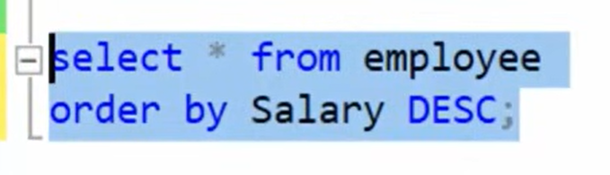

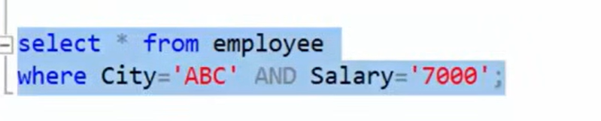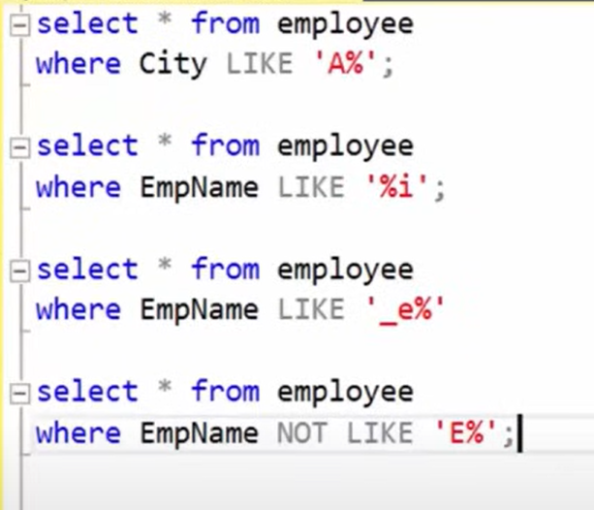

**Aggregate Functions(min, max, avg, count, sum)**

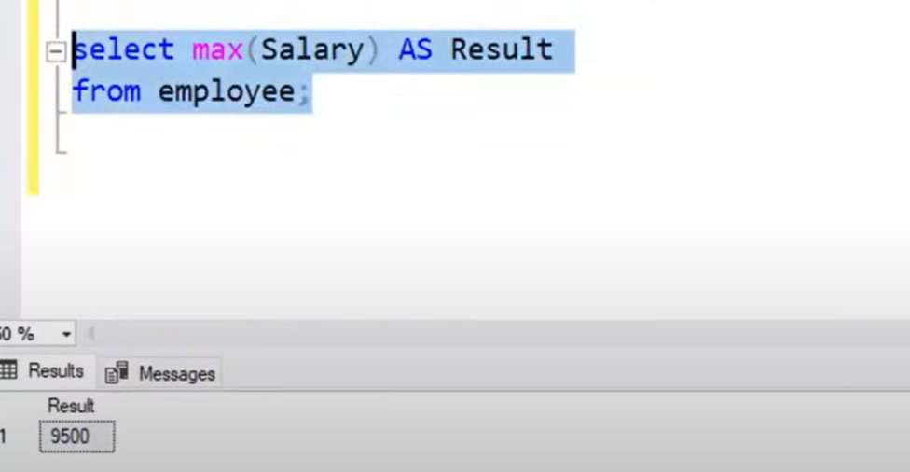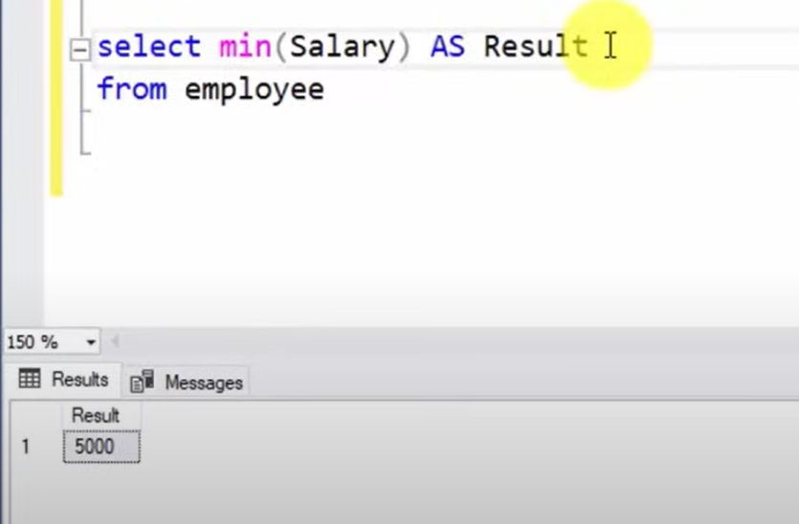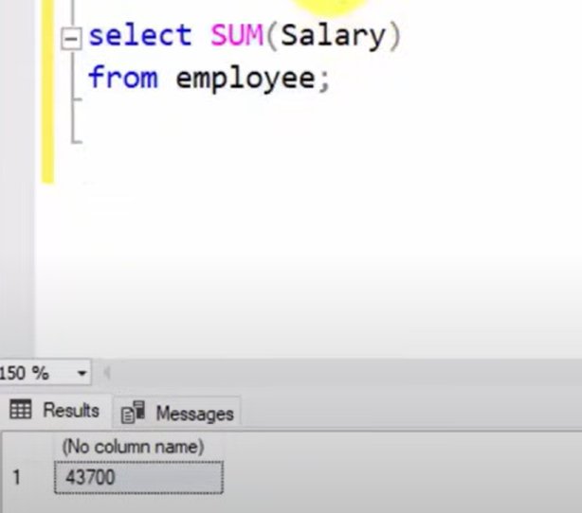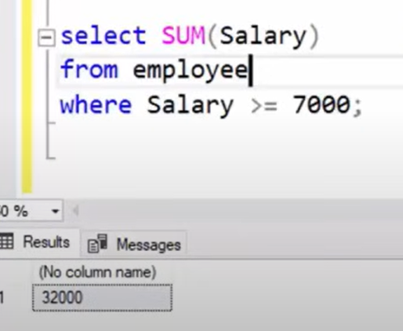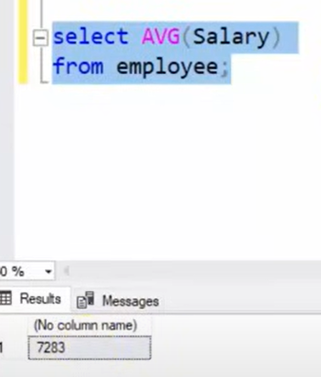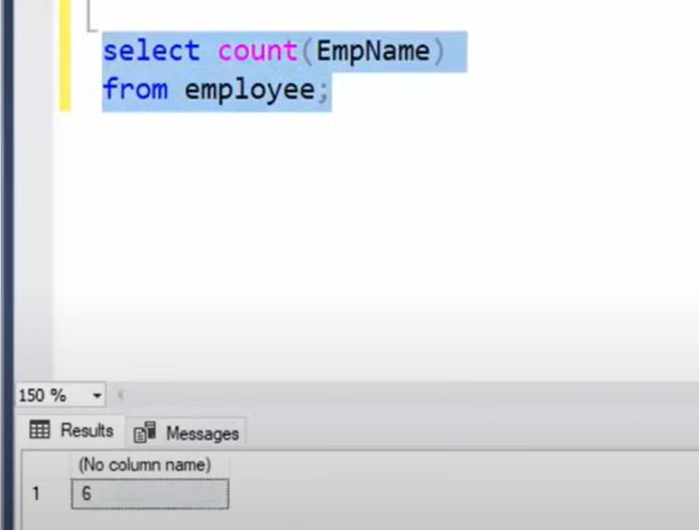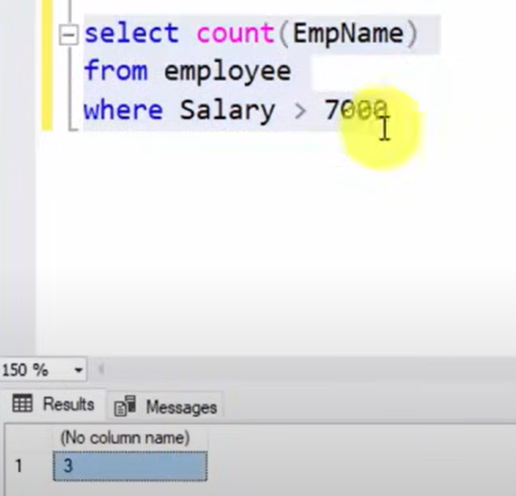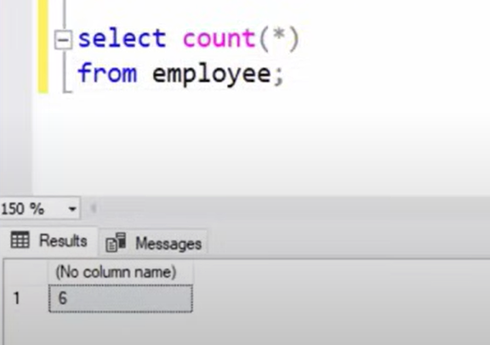

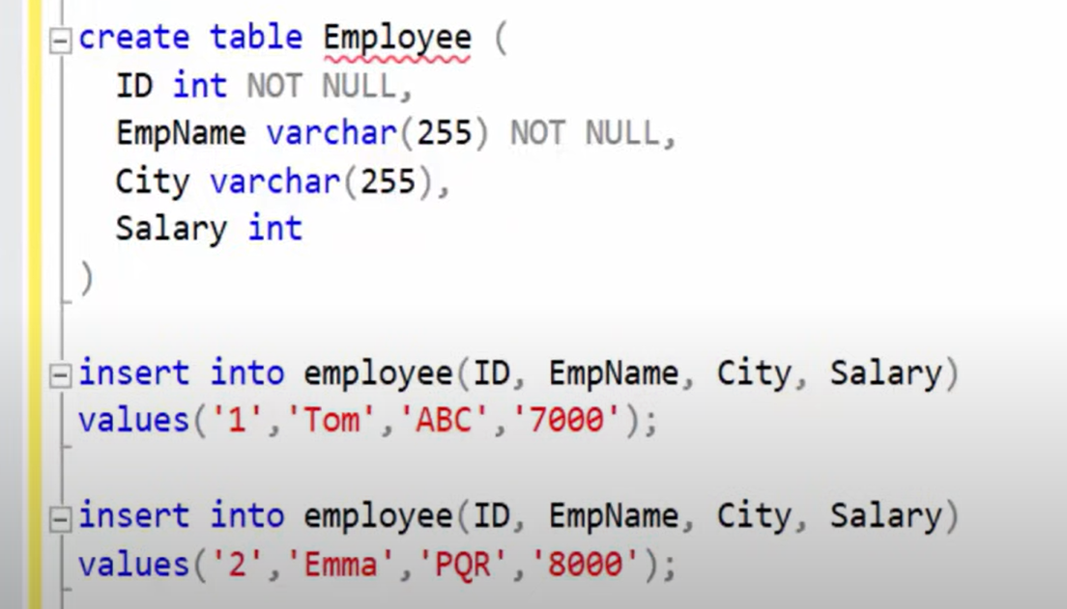

**Foreign Key**

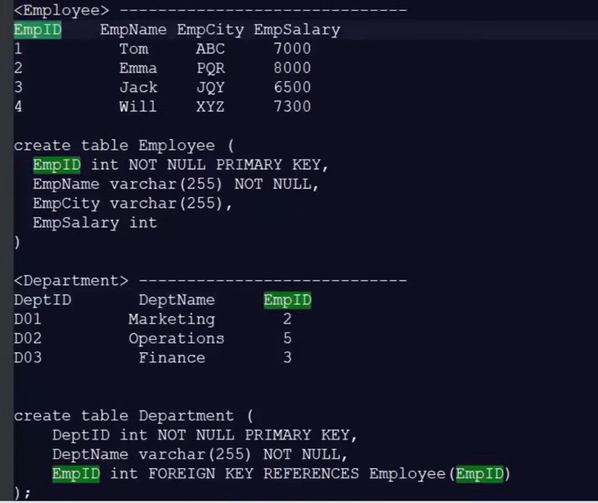

**CONSTRAINTS:**

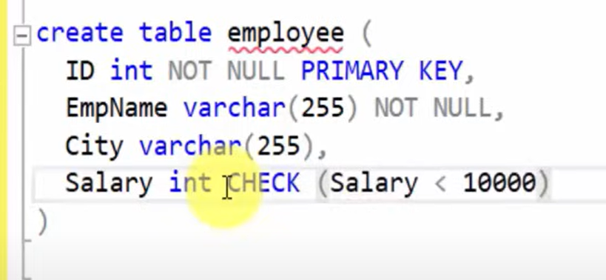

**ALTER TABLE**

ADD Column

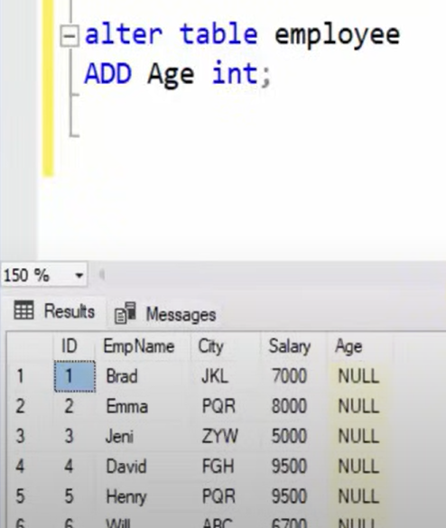

Delete Column



**Update TABLE**

 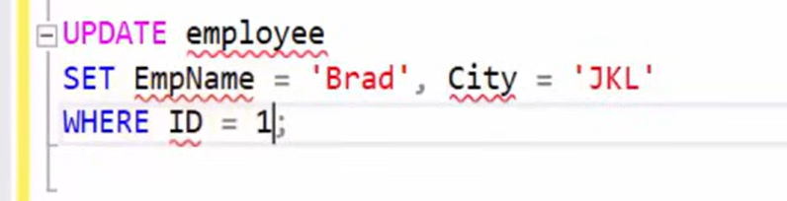

**SQL Aliases**

Temporary name to columns and table

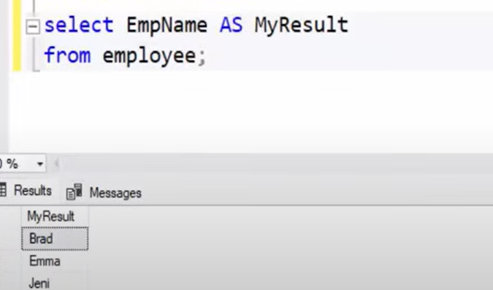

**Stored Procedure**

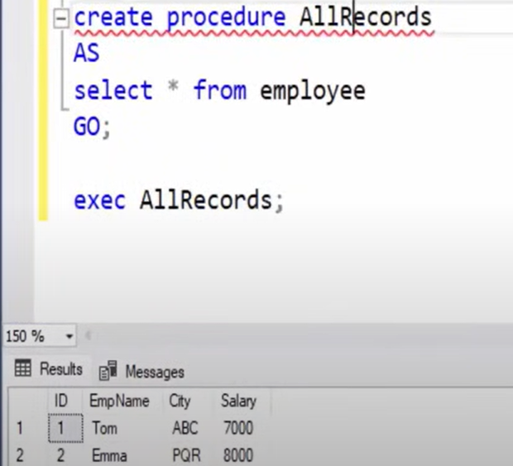

Stored procedure with single parameter

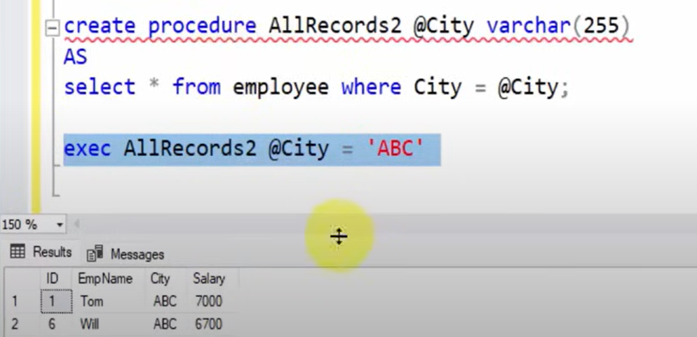

Stored procedure with multiple parameter

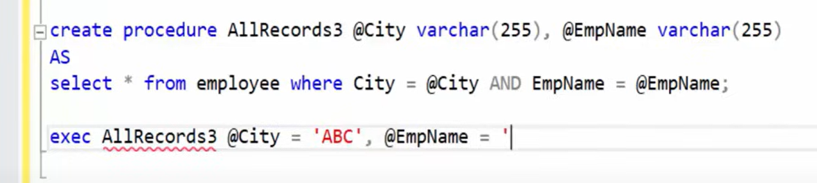

**Index in SQL**

**Retrieve Data Faster**

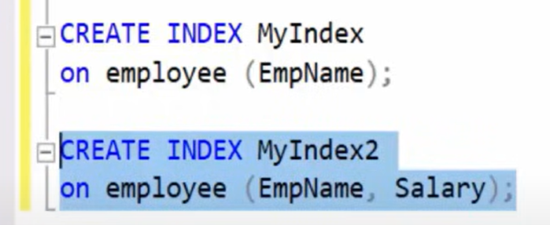

Drop index



**Select into Statement**

Make copy of table (for backups)



Add some columns only



**TOP Clause**

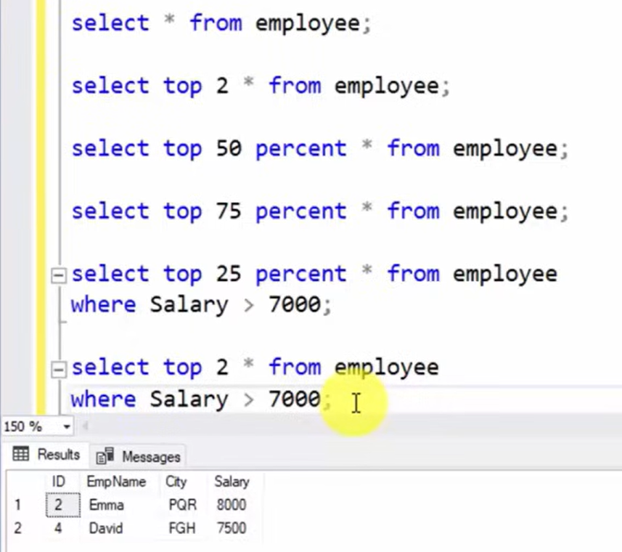

**Backup a database in SQL Server**



**View in SQL Server**

**(**Virtual Table**)**

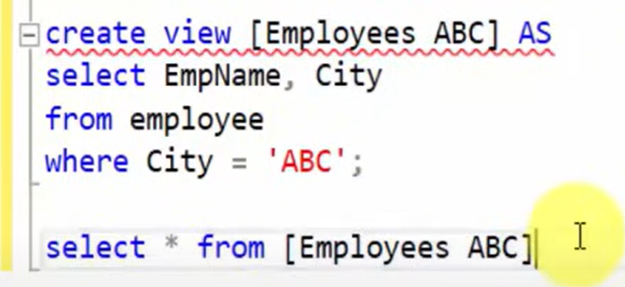

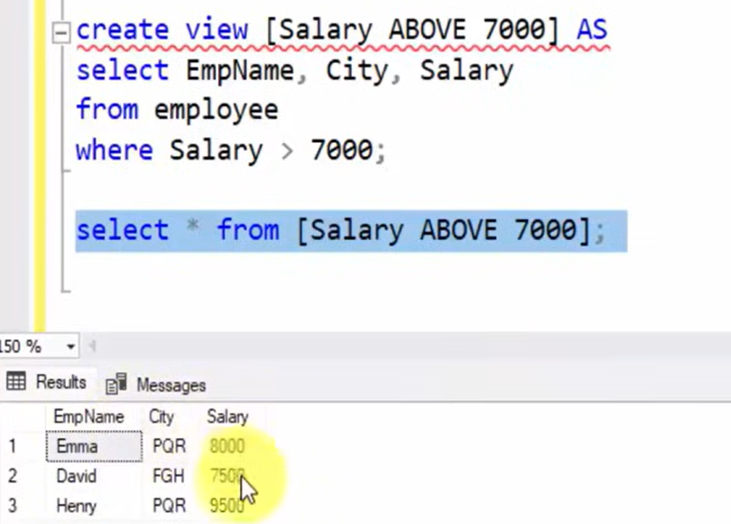

**Delete view**



**Drop Table**



**JOINS**

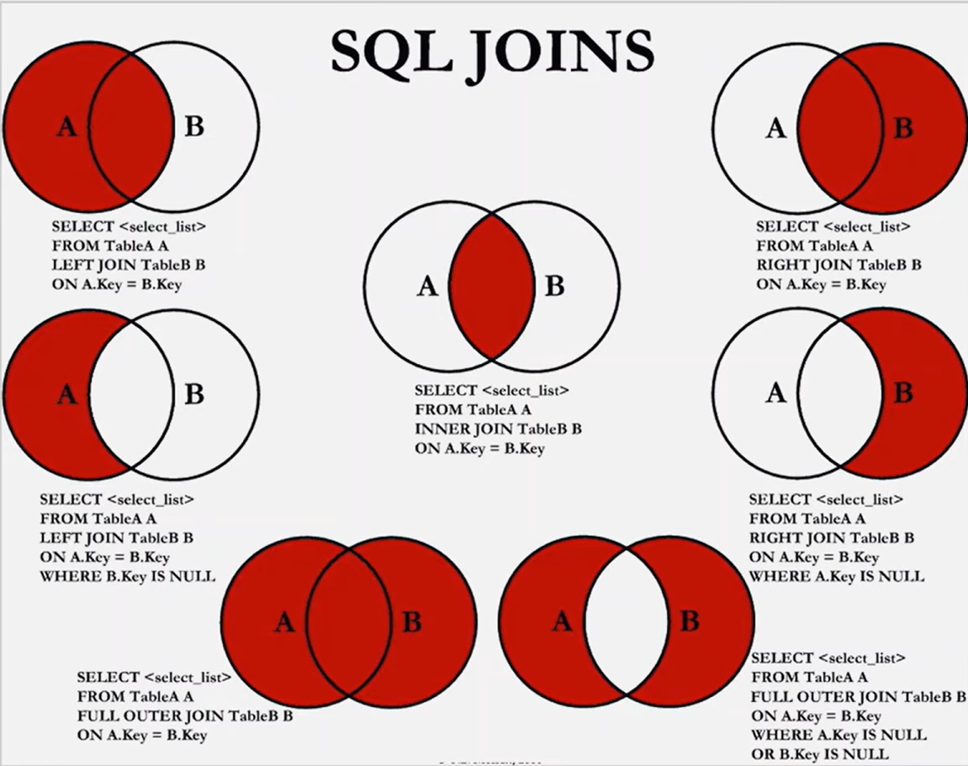

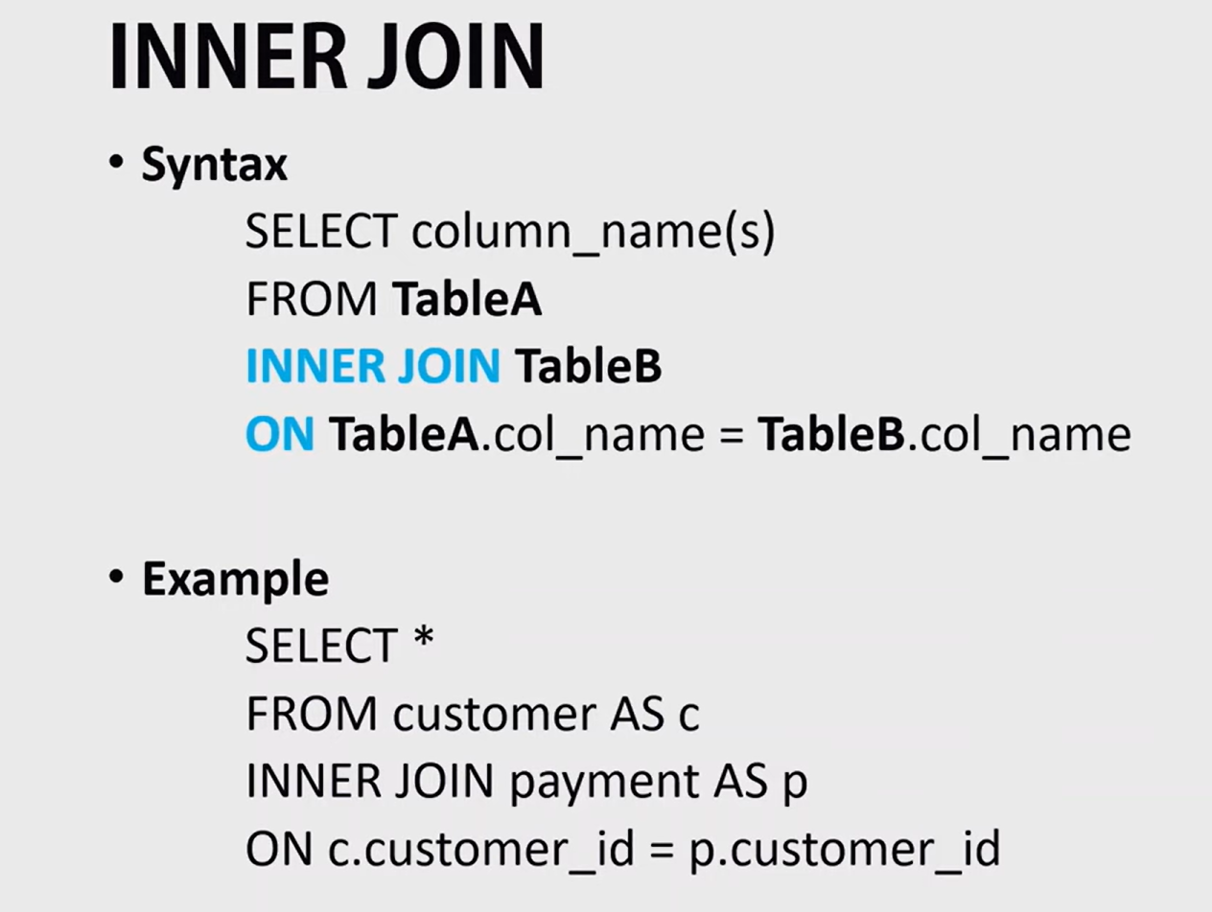

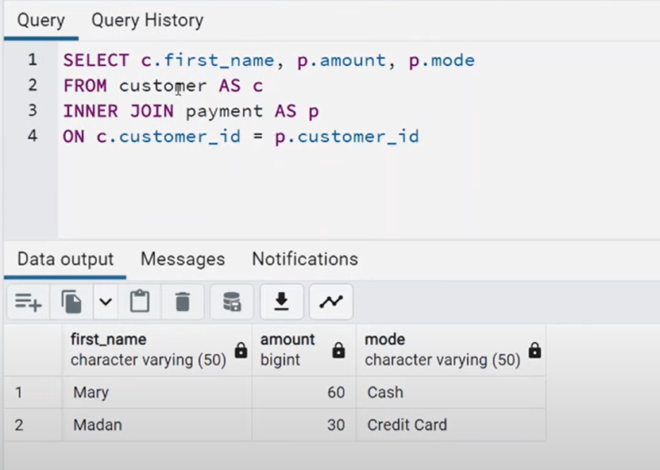

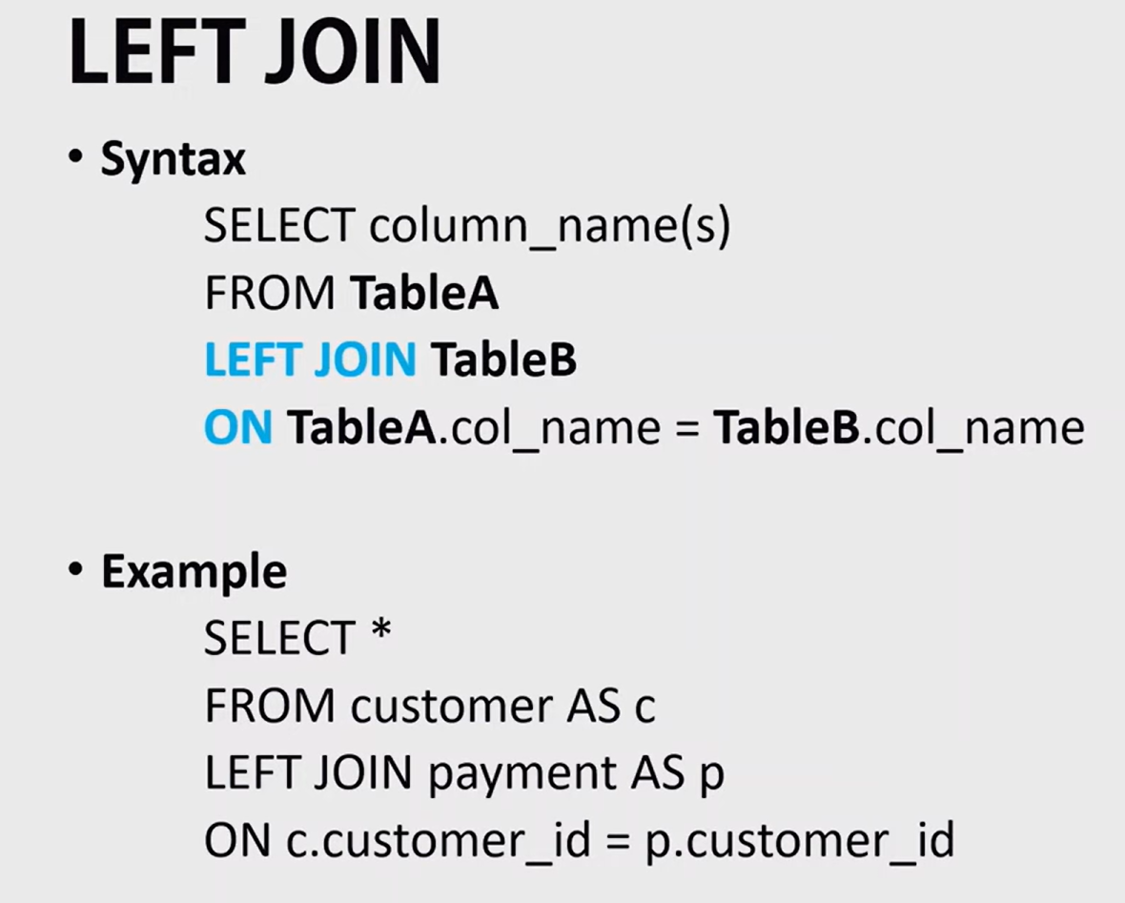



**Trigger**

